**Branding**

**Header Text Font**

1. Gistesy
2. Open Sans Bold

**Secondary text:**

1. Open Sans Regular

**Color Palette:**

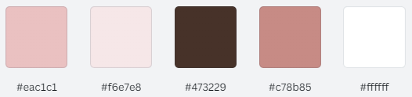

#eac1c1

#f6e7e8

#473229

#c78b85

#ffffff